October 2022 Newsletter
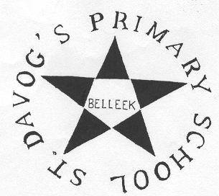
St Davog’s Primary School
14 Boa Island Road, Finner, Belleek, Co Fermanagh BT93 3FJ
Tel : 02868658520 Email: gkeown677@c2kni.net

Important Announcement
Safeguarding Team
The Designated Teacher for Child Protection is Mrs Keown
The Deputy Designated Teacher for Child Protection is Mrs McGaughey
Governor for Child Protection:
Mrs Christine Gilmurray
The Chairperson of the School
Governors is Mrs Catherine Clayton.

New Term
Congratulations to all the children and staff who have worked very hard throughout the month of September and settled back to school. Special thanks to all the parents for their help and support in developing our school playground. The children use all the playground every day and without the support of very hard working and supportive parents, the children would not have the opportunity to avail of an interesting, safe and secure playground. Your help is very much appreciated. Thank-you.
Halloween
School will be closed for Mid –Term Break on Friday 28th October and will reopen on Thursday 3rd November. Children can dress up in a Halloween Costume on Wednesday 26th October and there will be a costume parade in school. Children can bring one item of food for a class party in the afternoon.

Uniform Bank
The school is trying to set up a uniform bank in school, where the school can provide spare uniforms to families who may need items of school uniform during the school year. Children often tear trousers/jumpers in the school year and we would be able to provide clothing for school.
If you would like to donate uniforms that are in good condition and your children have grown out of, we would be very grateful of them and we can store them in school. We will be opening a uniform saving scheme in the new year where families can save for buying school jumpers by giving small amounts every week.
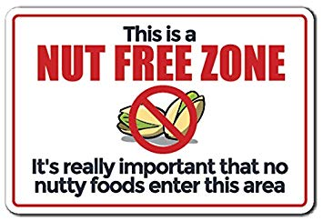
School Day
School Gates
The School gates will be closed at 9.10am when all children are in school. Could all parents ensure that the school gates remain closed during the school day.
Nut Free Zone
Due to health and safety concerns, St Davog’s is a nut free zone to ensure that there are no incidents of choking or allergic reactions.

All Children should arrive at school after 8.45am, leave their bags in their classroom and go to the School Hall where they will be supervised by a member of staff. Class begins at 9.00am when all teachers will bring their pupils to class. School ends for P1and P2 at 2:00pm from Tuesday 4th October and P3- P7 children at 3:00pm when all children will be brought to parents and carers by members of staff.
Homework
Teachers expect all children to complete homework activities every night. It is an opportunity for parents to work on a one to one basis to support their children’s learning. The teachers have updated the school policy and it is now available on the school website.
Health and Safety
- Car Park: In the interest of safety to the whole school community, Parents cannot drive into the school carpark in the mornings or evening to collect children. Exceptions can be made if a child/parent have physical needs. If you feel that you have significant needs, please contact Mrs Keown by telephone or email.
- PHA: Children who have been absent from school with a vomiting bug need to remain at home for 48 hours after they have been sick to minimize the risk of further infection in the classroom.
Parent/Teacher meetings
As all teachers are in class during the school day, parents are asked to contact the school office if they want to arrange a meeting with their child’s teacher. As Professionals, we feel that it is inappropriate to discuss a child’s progress or concerns in the playground or at home-time when children are being handed over to parents. Parent teacher meetings for children from P2 –P7 will be taking place on the week beginning Mon 7th November and teachers will be in contact to arrange meetings. Letters regarding the appointment time for meetings will be sent home with the children.
Reminder
Could all outstanding contributions to School Funds be paid as soon as possible.

