Margaret Rose McNaughton
Director of Transport & Food in Schools

To all School Principals | Rathgael House  43 Balloo Road  Rathgill  Bangor  BT19 7PR  Email: margaretrose.mcnaughton@education-ni.gov.uk
23 April 2021

Dear Principal

SCHEME TO DELIVER DIRECT PAYMENTS IN LIEU OF FREE SCHOOL MEALS AND SCHOOL HOLIDAY FOOD PAYMENT GRANT SCHEME SURVEY
You will be aware that the Department of Education has been running two similar but separate payment schemes, a scheme to deliver Direct Payments in lieu of Free School Meals and the School Holiday Food Grant Payment Scheme, to try and ensure that children who are entitled to Free School Meals do not suffer further hardship as a result of the Covid-19 pandemic.
The Department is evaluating the effectiveness of both of these schemes and has designed a short online survey for parents to complete – it should take no more than 2 minutes. The findings of the survey will also help inform future policy work on alleviating food poverty.
It would therefore be very helpful if you could send the link to the survey to all parents in your school using the suggested text provided at Annex A. The questions in the survey have been designed in such a way to also facilitate parents who are not eligible for free school meals to complete the survey if they wish.
I am aware that you are extremely busy, but I would be very grateful for your assistance in this matter to ensure we can best support these vulnerable families.
Yours sincerely
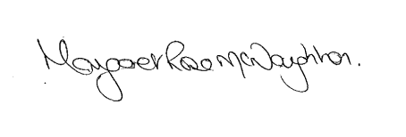
MARGARET ROSE McNAUGHTON

Annex A

Dear Parent
DE needs parent’s views on the Scheme to deliver Direct Payments in lieu of Free School Meals and the School Holiday Food Grant Payment Scheme.

DE Payment Schemes Survey

The Department of Education is currently evaluating the effectiveness of the two similar but separate payment schemes: a scheme to deliver Direct Payments in lieu of Free School Meals and the School Holiday Food Grant Payment Scheme. These schemes have been providing financial support of £13.50 per child per week, as necessary, to families of children entitled to Free School Meals since the start of the Covid-19 pandemic.

I have been asked to forward you the attached link to a short survey which will also assist the Department of Education in planning for any future payment schemes. I would encourage you to complete the online survey - it should take no more than 2 minutes.
We are especially interested in the views of parents whose children are entitled to Free School meals.

