At our last eco meeting one of the things the committee wanted to do was to promote our clothing bank. Thank you to everyone who uses our bank already.
After the Halloween holiday we will have a BIG recycling day when the Cash for Clobber van will visit our school.
This will take place on the week beginning 13th November.
The exact day will be confirmed after the Halloween break.
Items suitable for donating:
Clothes Pairs of shoes
Hats Scarves
Bedlinen Curtains
Towels Belts
Handbags

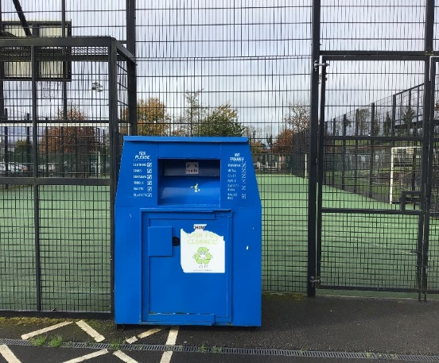

Thank you,
St.Davog’s eco-committee

