St Davog’s Primary School
Belleek

School Prospectus
2023-2024

Dear Parents / Guardians,

St. Davog’s PS has been providing quality teaching and learning experiences in the parish of Inis Muigh Samh for over 40 years for primary school children. It is a caring place, where children grow and learn, and where the entire school community aims to do its very best for all children in it’s care.
The children are at the centre of all our work in this school and we believe their interests and happiness are paramount. We believe that children learn and teachers teach best when they are happy and valued, so the development of high self-esteem in all our children is very important. Each member of our school community should feel a sense of belonging and feel valued and know that their views and opinions matter a great deal.
St. Davog’s PS is a Catholic school. We aim to foster the Catholic values for life, through our work in close partnership with the parish community and with parents / guardians. This is an important link which is valued and is built on mutual respect between staff, parents and pupils. We also welcome children of different faiths and children of no faith.
This booklet intends to give you a brief insight into school life in St Davog’s PS and it outlines the many opportunities and experiences available to children here. As a teaching staff, we aim to give many opportunities to our children to allow them to gain success in both academic and non-academic subjects. If you require further details on any aspect of this book, please do not hesitate to contact me.
A booklet such as this only gives you part of the story. Therefore, I invite you to visit our school so that you may experience the atmosphere, the interactions and the learning experiences which take place. You will be able to witness how your child will fit into St. Davog’s PS and how we will endeavour to meet all your child’s needs.
I take this opportunity to welcome you and your child and hope that you will be happy as you embark on your educational experience with us.

Yours sincerely,

Mrs Geraldine Keown
Principal
Mission Statement
We, the Governors and staff of St. Davog’s PS, believe the school to be an integral part of the community, welcoming children of all faiths and cultures. As a Catholic Maintained Co-Educational School we are committed to the aims of Catholic education and in our work, consider the uniqueness and individual needs of all children by delivering a broad, balanced, differentiated and effective education in accordance with the Northern Ireland Curriculum.

We aim to prepare children as life-long learners through a wide range of experiences in a safe and secure environment, where they are respected, valued and cared for as individuals and where EVERY child matters. We aspire to motivate, support and inspire personal, spiritual, emotional and educational development in all our pupils in a holistic and inclusive way.

As a school community, we endeavour to develop strong links with pupils, parents, staff, governors, parish, the local community and all outside agencies who work with us, to provide a quality education for all our children.

School Aims

- To create a warm and friendly atmosphere where every child is valued as an individual.

- To promote the Catholic ethos and a system of pastoral care for each individual in an atmosphere of Christian values, while also embracing an inclusive policy and atmosphere for pupils from all faith backgrounds

- To provide an inclusive, broad and balanced curriculum to ensure that all pupils have access to the Northern Ireland Curriculum regardless of their educational, physical, emotional or other needs at a level appropriate to their development

- To develop and maintain good home-school links, making parents welcome, making them aware of the school aims and their individual child’s needs, so that children can benefit from teachers and parents working as partners in their education

- To develop in children an understanding and appreciation of their own culture and tradition whilst also fostering in them tolerance, respect and mutual understanding of others through programmes such as PDMU.

- To maintain acceptable forms of behaviour within a structured and managed environment where positive attitudes are encouraged.

- To provide teaching and learning experiences which meet the special needs of all children.

- To provide children with a stimulating learning environment where they can become confident, independent learners and have equal opportunities so as to develop themselves as individuals and also to become contributors to society, the economy and the environment.

- Liaise with the Board of Governors and develop effective communication between all members of the school community.

Board of Governors
The Board of Governors constitutes members of the community, parents and staff members who come together on a regular basis to set the goals for the school. They meet with the Principal once a term and on occasion as necessary. The current Board of Governors is listed below:
Trustee Representatives Fr Tiernach Beggan
Mrs Clara Slevin
Mrs Catherine Clayton
Mr Dermot O’Reilly
EA Representatives Mrs Catherina Cox
Mr Paul Fannon
DENI Representative Mr Donal O’Reilly
Parent Representative Mrs Christine Gilmurrray
Staff Representative Mrs Leighann McBreen
Principal (non-voting) Mrs Geraldine Keown

Governors are responsible for the overall management of our school. Their duties include:
- The curriculum
- Selection and promotion of staff/personal responsibilities
- Admissions Policy
- Child Protection/discipline
- School Maintenance
- Implementation of new legislation
- Fostering links with the local community and pursuing the objectives of Education for Mutual Understanding
- Salary Policy
- Equal Opportunities

Staff

Year 1 Mrs Leighann McBreen/Miss Eimear Carty
Year 2/3 Miss Sinead Falconer/Miss Katie Gray
Year 4/5 Mrs Sinead McGaughey
Year 6/7 Mrs Geraldine Keown/Miss Carty

P1 Classroom Assistant Mrs Pauline McCann
Classroom Assistants Mrs Eileen McShea
Mrs Laura Curran
Ms Tracy McGloin
Mrs Geraldine McGarrigle
Mrs Christine Gilmurray
Mrs Elaine Doogan
Mrs Irene O’Loughlin

Administrator Mrs Teresa Heron

Site Supervisor Mr Noel Ferguson

Kitchen Staff Mrs Geraldine Lannon
Lunch Supervisors Mrs Christine Gilmurray
Mrs Eileen McShea, Mrs Laura Curran
Sports Coach Mr Shane Brennan
Mr Ultan Kelm

Chaplain Very Rev Fr Tiernach Beggan PP

Some curriculum support is also available from the Learning Support Services. Qualified coaches provide Fundamental skills training for Primary 1 to Primary 3 and GAA football and hurling skills for Primary 4 to Primary 7.

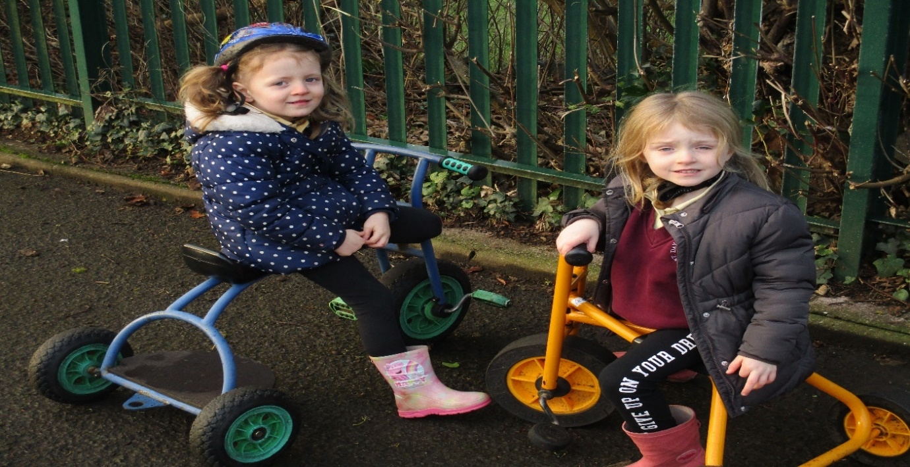

P1 children taking part in outdoor play developing their gross and fine motor skills

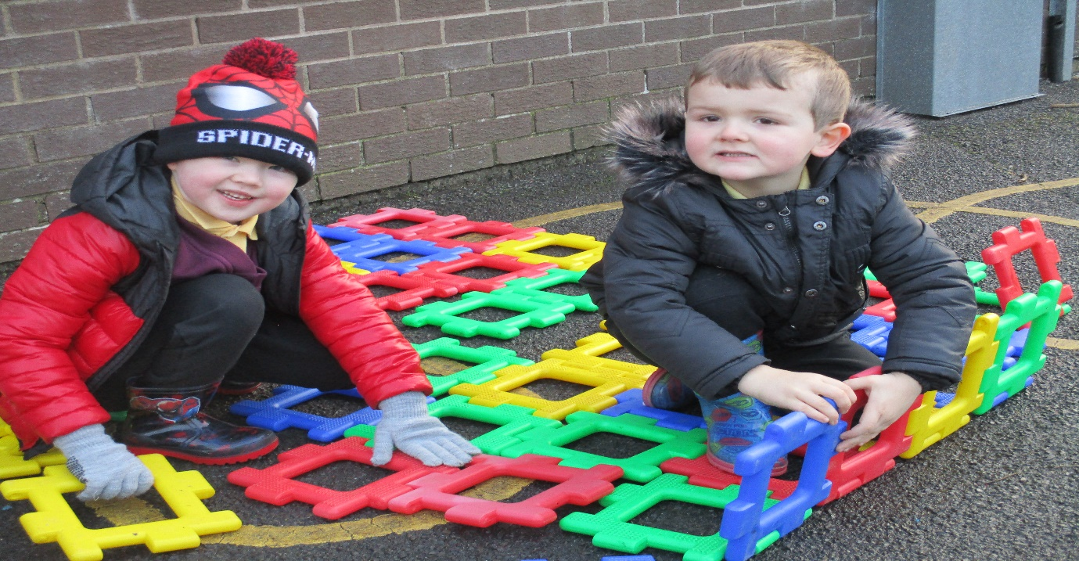

SCHOOL HOURS

The school day begins at 9.00am and children should be in their classrooms at this time. Children will be admitted to the school from 8:45am onwards. Children should not arrive at school before 8:45am and no responsibility can be taken by the school for any children arriving on the premises before this time. Parents of the younger children are invited to go into the classroom with them and help them to settle down during the first few minutes of the day.
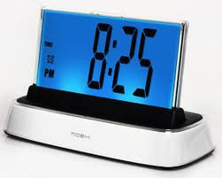
Morning break 10:40am – 11am
Lunch 12.30pm to 1.30pm
P1-2 day ends 2.00pm
P3– 7 day ends 3:00pm
.

TRANSPORT

The school is serviced by a number of Education Authority buses. In the interests of health and safety parents are advised to accompany children to the bus in the morning and be present when their children disembark in the afternoon. At home time children are accompanied to their parents and bus safely by teaching staff.
Parents of children travelling by car are asked to be punctual in collecting their children in the afternoon. P1-2 teachers will bring their pupils to the front door at 2.00pm and teachers will be available to bring the children from P3-P7 to the school door and to the school exit gate at 3:00pm. For safety reasons parents are asked to park in the public car park. Children will not be allowed to leave until a parent / guardian or other designated person has arrived to collect them.
Parents collecting Primary 1 and 2 children should walk to the school to meet their children.

The Education Authority has a new, online process for parents applying for home to school transport assistance. Applications for transport assistance to all schools, primary and post primary should now be completed online via the EA website at www.eani.org.uk/transportapp. Parents making a new application should be encouraged to apply before July 2023 as an offer of transport assistance cannot be guaranteed for 1st September 2023 if they make an application after this date.

SCHOOL UNIFORM
School uniform is part of our identity and represents what our school stands for. It is particularly important that the children wear sensible footwear, whether indoors or out, runner type shoes should be worn indoors.
The school uniform is: -

Grey trousers/grey skirt
Maroon sweatshirt with school logo/ maroon cardigan
White shirt and maroon tie
It is essential that all children’s clothing is clearly labelled to minimise the risk of losing uniform.

Pupils are expected to wear the above everyday unless special clothing is required such as PE days or school trips. Uniform jumpers can be purchased at the school office. For PE, children are advised to wear grey/ black tracksuit bottoms (shorts in summer), a yellow polo shirt and runners.

Appearance
Pupils should wear their uniform neatly and wear appropriate coats etc. in the winter. Pupil’s hair should be kept neat and tidy. Please ensure that if your child has long hair, they use a hair bauble, clips or hairband to keep the hair out of their eyes, when working.

SCHOOL MILK AND DINNERS
Milk is available for all children at a charge of 20p per day. Letters go out from school when payment is due.
We follow a Healthy Eating Policy in our school and all children are encouraged to eat a healthy break – fruit or vegetables. We ask parents to support us in helping our children to make healthy choices so please do not send sweets, chocolate, crisps etc.

Dinner costs £2.60 per day. Some children may be entitled to free meals and an application form may be obtained from Education Authority Western Region, 1 Hospital Road, Omagh, Co. Tyrone, BT79 OAW. Dinner money can be paid on the day that it is ordered but it must be paid on the last day of each week. A menu is available from the school at the beginning of each academic year. Children taking lunches are asked to adhere to our healthy eating policy and should not include chocolate, nuts or fizzy drinks.

Our school is a nut free zone to safeguard any children who may have nut allergies. Please check the ingredients on pre-packed foods.

If you are sending money to school with your child please put it into a sealed envelope with your child’s name, class and amount of money enclosed and what it is for, marked clearly on the outside.

ATTENDANCE
Children should attend school every day unless they are sick. If your child does have to miss school through ill health, or for any other reason, parents should call the school on the morning of the first day of absence. On a child’s return to school a note must be sent into school explaining their absence so that this may be recorded. Registers are marked in the morning and afternoon so if your child needs to attend an appointment, please notify his/her teacher in advance.

Regular attendance is essential to learning in school and all records of attendance is forwarded to the relevant authorities.

LINKS WITH OTHER AGENCIES
St Davog’s PS has an integral role to play in the parish of Inis Muighe Samh. We take every opportunity to contribute to the life of our parish and facilitate it in every way possible. Our Chaplain; Fr Beggan, is a regular visitor to the school helping to prepare children for the sacraments.

We have very good relations with our local Post Primary Schools and work closely with them to ensure that the transition between Primary and Post Primary is an easy one. Visits for Primary Seven children are arranged in the summer term and throughout the year children are invited for various sporting activities.

Additionally, the transition from Nursery to Primary School is enabled through visits to nursery, a buddying scheme and an induction day for new children and parents. We also enjoy close links to the local primary schools in the area. Neighbouring schools cluster together to plan curriculum and share resources as well as taking part in sporting activities. The school has developed links with St. John the Baptist PS, St. Martin’s PS and Belleek PS under the umbrella name of the Erne West Learning Community.

We co-operate with Health and Social Services and seek help when necessary. Visitors such as the school nurse, the school doctor and educational psychologist are welcomed and valued. The school Library Service offers a vital service and provides us with essential resources to provide the curriculum. We appreciate the support we get from Education Authority Western Region in terms of training and advice and avail of their services as appropriate.

MEDICAL

The school nurse and school doctor visit the school yearly and parents are notified and encouraged to attend if their child is being medically examined.

It is important to discuss any relevant medical problems concerning your child with the Principal or class teacher, as it will help us to do the best for your child. All such information is received in confidence.

Pupils should not be sent to school if they are unwell. Teachers are not required to administer medicines. Children with conditions such as nut allergies or epilepsy will be cared for appropriately and all staff will receive training to administer emergency medication. Each request for the administration of medicines will be considered individually and will require a medication plan to be drawn up. Antibiotics and other general medicines should be taken outside school hours. Inhalers will be kept by the teacher and full written instructions as to the frequency of use etc. should be provided. It is the parent’s responsibility to ensure that medication is in date and to dispose of out of date medication. If a child becomes unwell or has an accident whilst at school, the parents/guardians will be contacted by phone so that they may take the child home or to hospital, if required. It is essential that the school office is provided with up to date contact numbers to ensure that they can be contacted at all times.

NO SMOKING/DRUGS

The school has a no-smoking policy. Children are given the knowledge, information, understanding and skills involved in the danger of smoking and drug taking to help them make informed choices within the context of a healthy lifestyle.

CURRICULUM
The curriculum of the school is designed to give a broad and balanced education to all children and to equip them with the necessary skills needed for modern society and at the same time reflecting the Catholic ethos that is in our school. When planning our curriculum, we take into account the individual needs of our children. The school provides experiences in all the areas of study of the Northern Ireland curriculum, which are:
- The Arts
- Language and Literacy
- Mathematics and Numeracy
- Personal Development and Mutual Understanding
- Physical Education
- The World Around Us
- Religious Education

The NI Curriculum is based on skills development. The child will be able to…

Cross Curricular Skills
- communicate learning
- use mathematics
- understand and use ICT

Thinking Skills and Personal Capabilities
- Manage information and transfer it to other learning
- Work cooperatively with others
- Show creativity
- Think and problem solve and to make decisions
- To be able to manage one’s learning

Assessment for learning
Assessment is a collaborative tool. Responsibility is given over to the student and with the teacher and peers they assess their own path or learning journey.

- Planning with the children
- Clear learning intentions
- Agreed success criteria
- Individual target setting
- Advice on how to improve
- Peer and self-assessment
- Celebration of success

Progress is mapped throughout your child’s educational career. A meeting is held in the first term and parents are reported to in the final term in the shape of a Pupil Profile.

ASSESSMENT, REPORTING AND RECORD KEEPING
Assessment of children’s work is an integral part of our school. The main purpose of assessment is to
- Establish through a variety of means what each child is capable of
- Assist the teacher in planning appropriate tasks for each child

As part of this, regular assessment takes place throughout the year with the results formally recorded by the teacher and reported to parents. The records of each child’s attainment and work samples are passed onto each successive teacher. We invite parents to discuss their child’s progress at the annual parent meeting in term one. Written reports are made available to parents at the end of the year.

SPECIAL EDUCATION PROVISION
Care is taken at all times to match the curricular provisions for all the children to their particular stage of development and to take account of any particular difficulties or special talents, which they show. We aim to identify children with Special Needs or Specific Learning Difficulties as early as possible. If a pupil displays a learning difficulty, he/she will be carefully monitored and assessed by his/her class teacher and worked with on an individual basis with the consent of the parent. If it is felt that the child needs specialised help you will be informed and with your permission the Educational Psychologist (Education Authority) will be informed and arrangements made to have the child tested and assessed. Following testing the psychologist may advise the teacher on an appropriate approach to tackle the problem or involve specialised outside help. In these matters we are guided by the procedures outlined in the Code of Practice. Mrs McBreen is the teacher responsible for co-ordinating special needs. If a parent has an issue concerning his/her child’s educational provision they should approach the child’s teacher. In turn the Principal will be notified and if satisfaction is not achieved the Board of Governors will be informed. (Special Needs Policy)

RELIGIOUS EDUCATION
Religious Education is central to the ethos of the Catholic Church and it aims to foster healthy moral and social values towards the child, family and society together with a love and appreciation of prayer.

Grow in Love is the basic R.E. programmes used but it is worth remembering that R.E. cannot be slotted into a half hour period but permeates throughout the day and is pivoted on the example and attitudes of the entire school staff. The Grow in Love programme has now been introduced to all classes from P1 –P7.
Common traditions (with others) are experienced through Halloween and Christmas traditions and celebrations.

MUSIC
The aim of the school is to make music an experience to be enjoyed by as many as possible not just the gifted and to foster a life-long love and appreciation for music. This means that choirs and performances contain children who enjoy singing, irrespective of their singing ability.

PHYSICAL EDUCATION
We aim to provide a broad physical programme which develops children’s skills and fosters a healthy lifestyle. It is important to deliver a range of activities which not only develop essential skills but also a sense of enjoyment, achievement and improved performance. Foundation and Key Stage 1 children take part in games, gymnastics, athletics and movement activities as do Key Stage 2 children who also attend swimming.
They also take part in sporting activities organised by GAA who provide coaching throughout the school (P1 – P7: football / P5 – P7: Hurling). The school offers Primary 6 children the opportunity to take part in the cycling proficiency scheme run by the DOE. Sports Coaches also attend the school providing athletics and training throughout the school.

PASTORAL CARE

Through Pastoral Care teachers and pupils work together to create a caring and supportive atmosphere in our school. Great care is taken to help Primary One children settle into their new environment. Preliminary visits are arranged in the summer term for children and their parents. Parents are invited to an information meeting to receive information about the school and how parents can best support their children’s learning. New experiences are introduced gradually over the first weeks of September. In October or November parents are invited to discuss initial observations made and programmes of work for their children. Other classes hold their parent/teacher meetings at the end of October or November where parents have the opportunity to discuss their children’s well- being and progress.
Children and parents should inform the class teacher if problems arise. Complaints and concerns will receive immediate attention and action will be taken where appropriate.

CHILD PROTECTION
We believe that every child has the fundamental right to be safe from harm and deserve to have proper care given to their physical, emotional, and spiritual well-being. We as carers, teachers, non-teaching staff and volunteers must therefore take responsibility to help protect the children within our care from abuse or the risk of abuse of all kinds.
Through our Pastoral Care Policy, we aim to provide a caring, supportive and safe environment in which each child feels valued for who he/she is and for their particular talents, abilities and contributions and we strive to create an environment in which each child can learn to develop his/her full potential gaining confidence and self-worth. We discourage children from using aggressive behaviour and encourage alternative methods of response. We also aim to create a listening environment within our school where children are given a voice and are listened to.

We recognise however, that abuse exists and that there are four types of abuse – neglect, physical abuse, sexual abuse and emotional abuse. The Department of Education in NI requires all those working in education to co-operate fully with social services and other agencies to protect children. It is therefore our duty to refer if there is a concern about any form of abuse. If there is a concern the Designated teacher is informed (Mrs Keown/Mrs McGaughey). The Principal is told and a plan of action agreed following advice from the Child Protection service and other authorities. If they decide to refer then Social Services, EA and CCMS are informed otherwise the parent is informed of the schools concerns if this is appropriate. The school will continue to support and monitor the child/children throughout. Confidentiality is paramount and only involved parties will be aware of the situation.

If you have a concern for the welfare or safety of your child, contact your child’s class teacher to make an appointment. If not satisfied with the outcome you may speak to the designated teacher for pastoral care, Mrs McGaughey - or to the Principal. A leaflet outlining Child Protection procedures is available with this prospectus. Full details of policy and procedures can be obtained from the school on request.
Parental consent is sought before the school displays images of pupils in the school, in the newspaper or on our website. A permission slip will be completed for all new entrants to inform us if we can use photographs of your child/children. If at any time in the future, you wish to withdraw permission, please inform the school in writing.
Children are not allowed to carry mobile phones. If parents need to make contact with children, a message can be left with the school secretary who will pass on the message. We prefer that children are not directly given information which may cause stress or anxiety.
Internet use is strictly filtered by the C2k network. Children have regular access to the internet for educational purposes and they are taught about internet safety.
A buzzer system provides security within school, strictly controlling access to visitors. The front door operates on an electronic release mechanism controlled by the Secretary’s office and by the P7/Principal’s classroom. Visitors may be asked for identification and all are required to sign the Visitor’s Book upon entry/exit to the school and wear a visitor’s badge while in the school building.
The Designated Teacher for Child Protection is Mrs Geraldine Keown.
The Deputy Designated Teacher for Child Protection is Mrs Sinead McGaughey.
The other members of the Safeguarding Team are: Mrs Catherine Clayton (Chair of BoG) and Mrs Christine Gilmurray (Governor with Responsibility for Child Protection).

POSITIVE BEHAVIOUR
Our school discipline policy is based on the school’s Christian beliefs and ethos. We feel that in a caring, organised, stimulated atmosphere all children should be suitably behaved and willing to co-operate so that good order and learning can take place and self-discipline and responsibility achieved. The positive aspects of good behaviour will be stressed and rewards for good behaviour and learning evident in each class and presented during whole school assemblies.

Teachers and parents have a responsibility to ensure that children behave in an acceptable manner. This creates a need for close co-operation between home and school. A minority of pupils may cause class disruption or show a non-acceptable pattern of behaviour. This will necessitate counselling, sanctions, extra work, loss of privileges and parental involvement.

SCHOOL RULES
Children are expected to behave in a way, which shows consideration for other people and their property. We expect them to treat both other children and adults with politeness, and kindness and to have a regard for the safety for themselves and/or others. Children are involved in the rule making process and are given the responsibility to maintain standards within the school. These rules are established in the first week of the new academic year. Children are also expected to adhere to good behaviour standards while working outside of school, using EA transport or during organised trips.

ANTI-BULLYING
Bullying is a highly distressing and damaging form of abuse and is not tolerated in St. Davog’s Primary School. The ethos of our school aims to promote a sense of self-worth, respect and fair play and this permeates the school curriculum.
All staff are vigilant at all times to the possibility of bullying occurring, and will take immediate steps to stop it happening and to protect and reassure the victim and to discipline the bully. Parents of both victim and bully will be personally contacted when such behaviour is identified.

HEALTH AND SAFETY
Every effort is taken to ensure that children are safe and secure in the school environment. Regular fire drills take place so that everyone may be evacuated from the building quickly. A security system is in place in the school building. Parents visiting the school at any time other than normal opening and closing times must report to the secretary’s office after being admitted.

HOMEWORK
In accordance with St Davog’s Homework policy, parental support is an invaluable part of a child’s learning. Children are very much encouraged to take books home to read and we encourage parents to try and find time to read with their children and to discuss their books with them. If parents need advice on the best way to tackle this, the child’s class teacher will be pleased to discuss this. Children will have specific work to complete at home. This work will be reinforcement activities that support learning from class.
Children may also be asked to undertake small tasks at home such as practice music, reinforce spellings or tables, or practice handwriting. The school welcomes parental support and encouragement for all such small tasks. Occasionally children will be asked (or will ask themselves) to complete a piece of work at home and again the school will seek parental support with this.

All children from year 4 upwards have homework diaries, they provide an important means of communication between home and school, and they allow you to know exactly what homework your child has to do and enable you to comment on their work. By checking your child’s homework each night, you are showing them that the homework is important. We expect all written homework from year 4 to year 7 to be signed by a parent. By signing the written homework, the teacher knows that you are satisfied that your child has completed their work to the best of their ability.

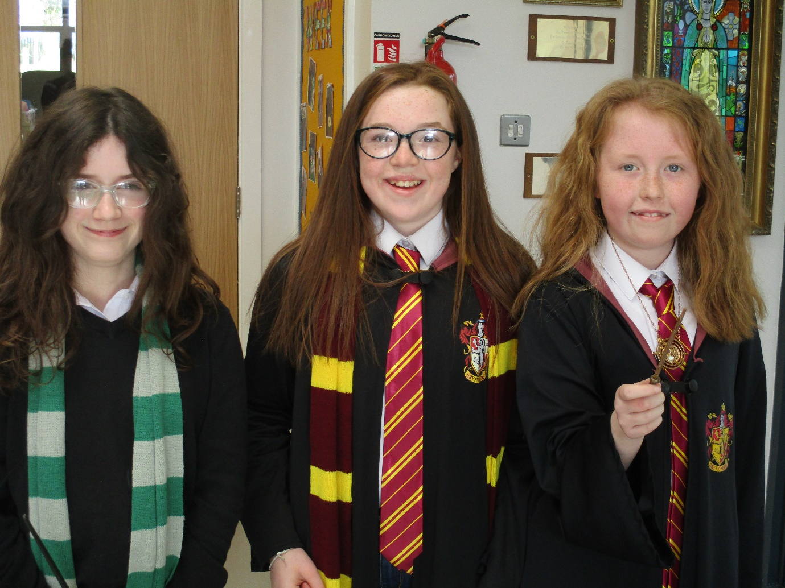

World Book Day March ‘22

ITEMS OF INTEREST

OUT OF SCHOOL ACTIVITIES
Educational visits are an important part of the learning process. Preparation and follow up takes a lot of time and the visit may be the central point of work undertaken. Letters asking for parental consent regarding trips are sent to parents at the beginning of the school year and information regarding specific requirements for education visits are sent to the parents prior to a trip.

LEARNING TOGETHER
St. Davog’s PS is part of the Extended Schools Education programme under the umbrella name of the Erne West Learning Community which comprises of St. John the Baptist PS, Belleek PS and St. Martin’s PS. It aims to develop mutual respect through shared classes, staff development among all staff and joint sessions which bring pupil and parents together.

HOLIDAYS
It is not recommended that children should be removed from the school for holidays, as this has a disruptive effect on their learning and progress. The school will not authorise any absence for this purpose. Should this be unavoidable, reading books may be provided to cover the missing period. A calendar indicating the planned school holidays and Staff Development Days for the following academic year will be distributed to all families in September to allow for planning of holidays and family events.

HOME/SCHOOL CONTACT
A school succeeds when parents and teaching staff work together. We have extremely good relations with parents and encourage parents to be actively involved in their children’s education and progress. You can help us by:
- Ensuring regular attendance and punctuality
- Developing positive attitudes toward school and learning
- Working with the teacher to ensure that their child achieves his/her potential
- Ensuring that homework is done to the best of the child’s ability
- Extending the learning which takes place in school

Parents should contact the school if they are concerned about any aspect of their child’s work to arrange a meeting with their child’s teacher. A request for an appointment is always helpful as the teacher or principal may be involved in other activities. However, a very urgent matter will be attended to without delay. The school secretary is available to make arrangements within these times: Monday – Friday 8:40am – 1:30pm

All parents will be invited to an individual meeting with their child’s/children’s teacher to discuss their progress. The Early Years teachers encourage parents to visit the school for informal discussions as they see fit. There are many other opportunities for staff and parents to meet. Some of these occasions will be on a formal basis and you will be notified in due course.

- Annual General Meeting for parents organised by the Board of Governors
- Annual Parent/Teacher Meeting
- Key Stage Two Transfer meeting in the Spring Term
- Pre-Sacramental Preparation Meetings

ROAD SAFETY
With so many fatalities on our roads we feel that road safety and safety in general is a crucial part of our curriculum. The school will strive, in partnership with those in parental responsibility, to educate children in the proper and safe use of roads, promoting safe behaviour and practice as well as an attitude that respects those dangers which will be encountered on or near roads. Parents are asked to encourage their children to behave appropriately and wear their seat belts while travelling on EA transport buses.

MONEY
Under the Education Reform Act of 1988, the Board of Governors of St. Davog’s PS shall provide the N.I. curriculum free of charge to all pupils. However, the Board of Governors invite voluntary contributions to school funds from parents in support of the school-based activities e.g. celebrations, trips and visits, which take place during school hours. Each family should contribute £20 per child and £10 for every second child.

Pupils may be charged:

- Fees for entering external competitions
- Tuitions for musical instruments during or after school hours
- For school trips or outings

CHARITIES
There is a strong tradition of support for many different charities, thereby developing in the children’s concern and consideration for others. Careful thought is given to the selection of good causes and the method of fund-raising in order to make it meaningful and appealing to children.

INSPECTION OF DOCUMENTS
There are many policy documents available for parents to view: anti-bullying, positive behaviour, child protection etc. If you do wish to view a document or wish to talk to the principal on any matter, please ring the school to make an appointment.

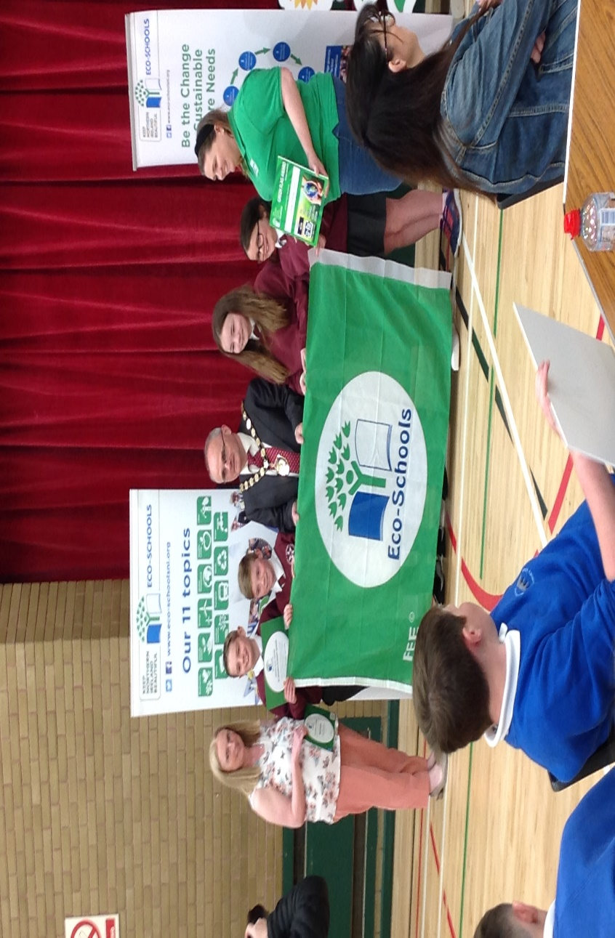
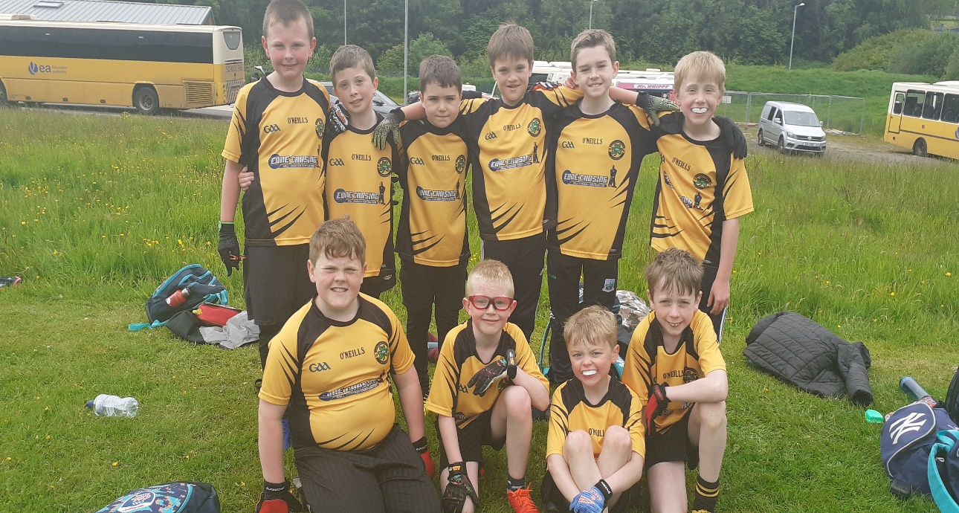
Life in St Davogs Primary School

7 a-side Gaelic Football

St Davog’s Eco Team receive their 1st Eco Flag award

End of Year Trip to Todd’s Leap
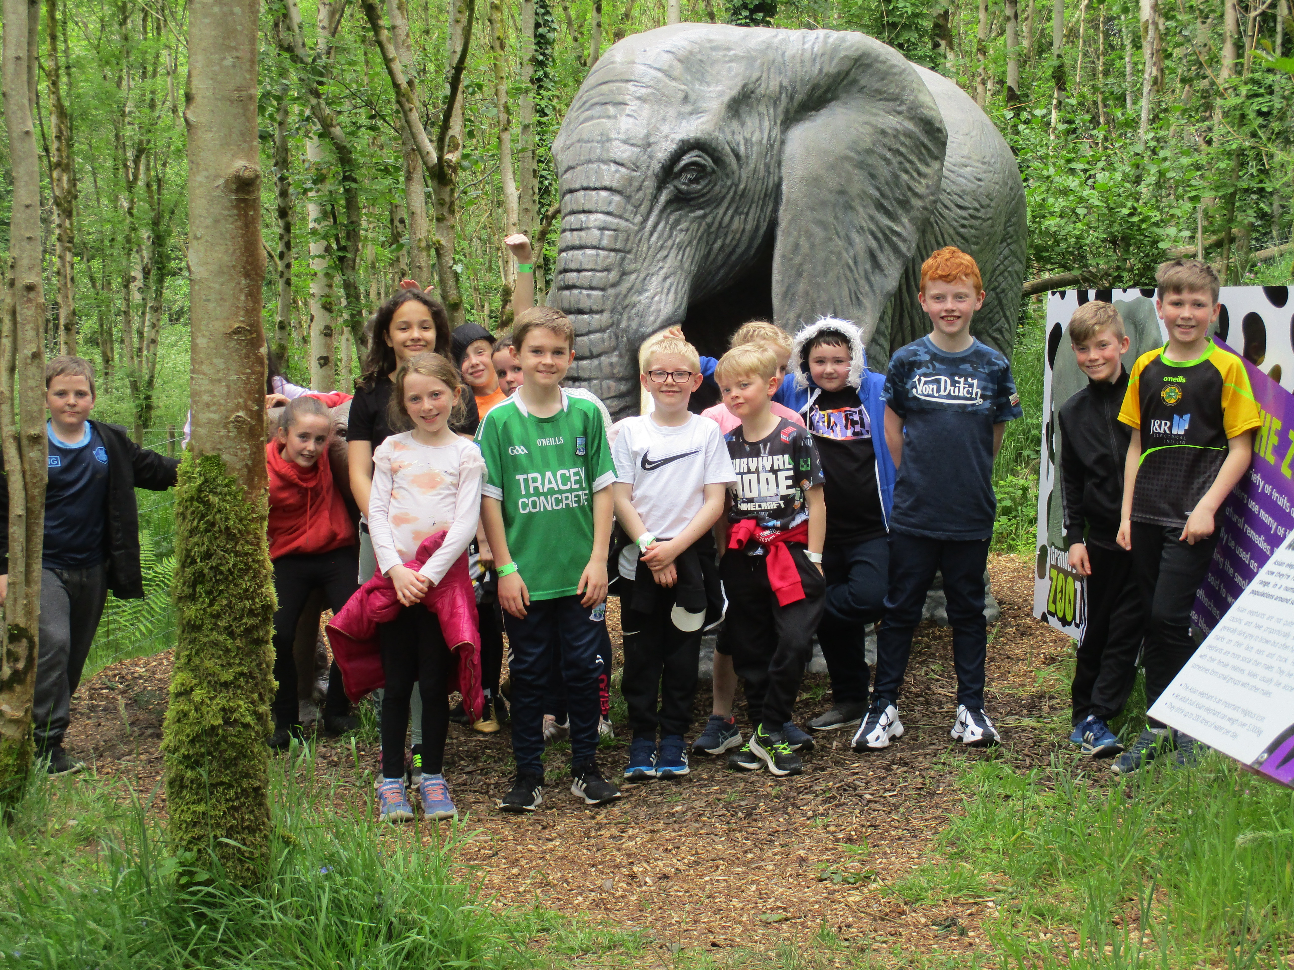
Using I-pads in P6 and P7 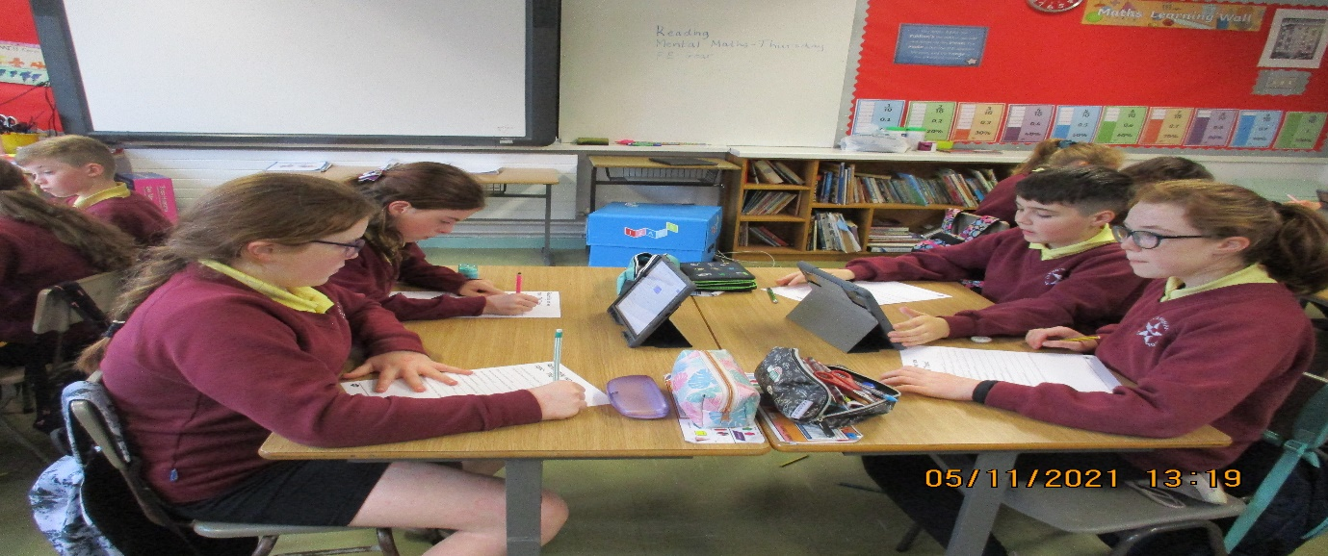Fun in P5
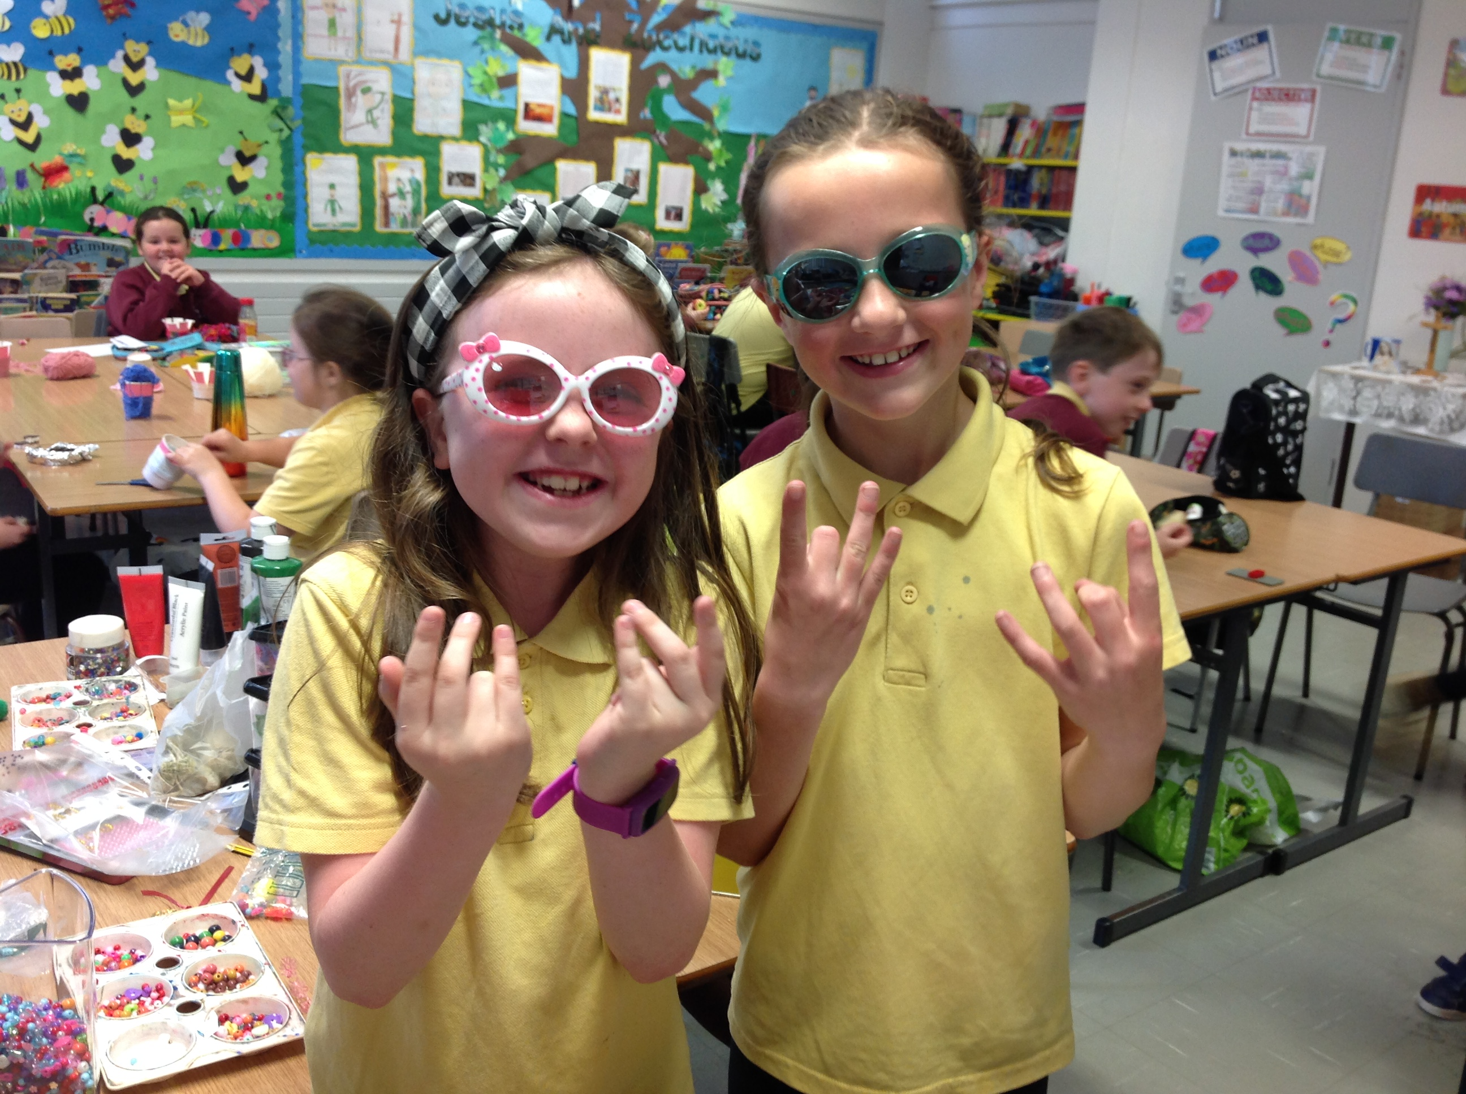
Life in Primary 1
Complaints Procedure

